Homework PACKET 2

iDAHO pUBLIC dRIVER eDUCATION

Traffic Control Devices, Laws, and Basic Vehicle Control

Warning Signs: Most warning signs are yellow diamond-shaped signs that warn drivers of possible dangers ahead. But SCHOOL ZONE, SCHOOL CROSSING, and NO PASSING signs are warning signs with their own shapes.
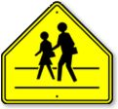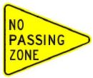

Guide Signs: Provide a variety of information, including ROUTE signs which tell you the name and/or number of the road you are driving on, green mileage signs to nearby destinations, blue signs that tell you about nearby services, and brown signs that indicate points of interest like national parks.
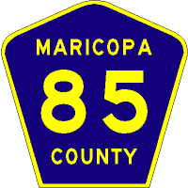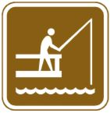

Traffic Lights

Green lights indicate “GO” but you still have to be aware of who has the right of way. For example, a green circle in a turn lane means “GO” only after you yield to oncoming traffic. Be aware of how long the light has been green so you can predict when it will be turning yellow and then red.

Yellow lights warn you to make every effort to stop safely. In Idaho if you are already in an intersection when the light turns yellow you can legally complete your passage through that intersection, though you should do it quickly and carefully. And you cannot enter an intersection if the light is already red.

Red lights mean STOP! When your light is RED it means cross traffic can legally enter that intersection at the posted speed limit.

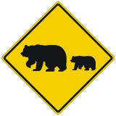
Traffic Signs
By recognizing and understanding the meanings of traffic signs you are able to stay one step ahead of knowing what to do in sometimes very complicated roadway situations. Take the bear crossing sign, above. Seeing this sign and knowing what it means before getting to the location where bear commonly cross the road might save your life, your car, and the life of a bear. The best actions to take when seeing this sign? Slow down and pay extra attention for movement along both sides of the roadway.

Signs are one of three types: REGULATORY signs, which tell you about laws you must obey, WARNING signs, which help you avoid dangerous situations, and GUIDE signs, which provide information.

Regulatory Signs: The most important regulatory signs are STOP and YIELD signs. They are so important they have their own unique shapes. All other regulatory signs are either white squares or rectangles with red or black lettering. The STOP sign is a red octagon with white letters and border and requires a driver to come to a complete stop at the intersection where it is posted. After stopping the driver must look for other vehicles and pedestrians and determine who has the right of way to go first. A YIELD sign acts much like a STOP sign but if slowing enough ahead of time and analyzing the intersection, you may not have to stop completely if you have the right of way.
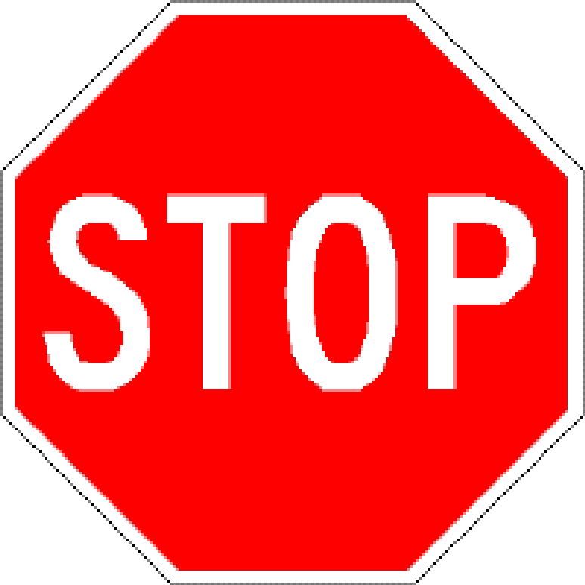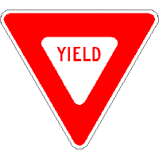

HOMEWORK PACKET 2

Idaho public driver education

Right on Red

All states allow vehicles to turn right at a red light but the vehicle must first stop completely and yield to any cross traffic.

Left on Red

Idaho also allows drivers to make a left at a red light. As expected, the vehicle must first come to a complete stop and yield to any cross traffic, but it can only be done onto a one-way street.

Doghouse Signals and Green Arrows

The sign above, known as a doghouse signal, is fairly common at intersections. If the green arrow is lit you have the right of way and can turn. If the green circle is lit you can turn only after yielding to oncoming traffic. And red means stop of course!

Roadway Markings
Signs aren’t the only means of telling drivers what to do and where to drive. Paint and other reflective markers communicate to drivers what is ahead.
Yellow lines separate two-way traffic. A broken yellow line allows a driver to pass another vehicle while a solid yellow line does not.
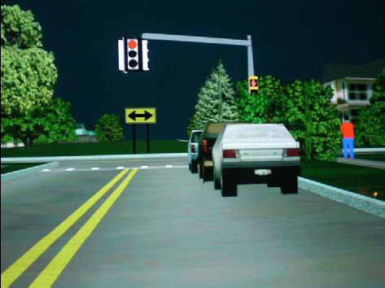

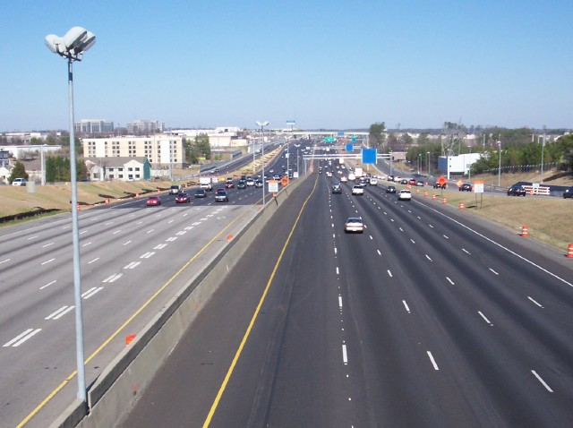
White lines separate lanes of traffic traveling the same direction. You may cross these broken white lines while changing lanes. Solid white lines indicate that you should not cross them. The solid white lines on the edge of a roadway are there to help you see the edge of the road at night or in other poor-visibility conditions. Solid white lines are also used at crosswalks where you must stop. These are called stop lines.

Some states, including Idaho, use grooves in the pavement, called rumble strips, to alert drivers to a hazard. You might find them near the edge of the road, in the middle of the road, or when approaching a dangerous intersection where cross traffic might not stop.

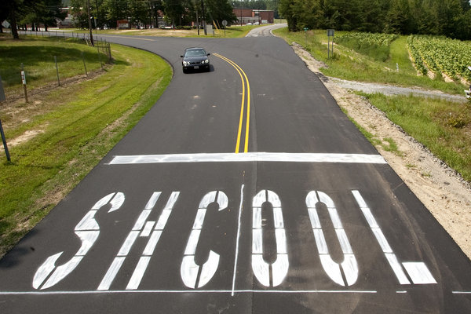

Other roadway markings include a large “X” and two “Rs” at a railroad crossing, the word “SCHOOL” at school crossings (like the one spelled incorrectly above!), and various parking lot markings to help drivers know where they can and can’t park.

Pay attention to all the signs around you to be a well-informed driver.
REVIEW QUESTIONS
HOMEWORK PACKET 2

NAME: _______________________________________ DATE: ____________

DIRECTIONS: Answer the following questions based on what you learned from the homework packet.

- Name the three TYPES of signs:

- Most warning signs are ______________diamond shaped.
- What color would a sign be that indicates a national park is ahead?
- True or false? A green light always means go without need to watch for oncoming or cross traffic.
- At a yellow light, why should you make every attempt to stop?
- Explain the law for turning LEFT at a red light.
- What do you in a turn lane with a green arrow?
- If you were the car in the graphic, could you legally pass the truck?
